

**Work Insight and**

**Skills Week**

**3rd August – 7th August 2020**

**London Cluster xxx**

**Student Information Pack**



## Students’ Joining Pack

Dear students,

Congratulations on securing a place on the SMBP Work Insight and Skills Week. In this pack you will find all the information you need to find your way to each of the work placement hosts.

For each day you are provided with:

* the location and directions to each business;
* the contact person you should ask for on arrival or contact if you cannot make it;
* your itinerary for each day.

Please remember you should aim to arrive at least fifteen minutes before the start time and allow plenty of time in case you get lost or transport is disrupted. You could think about meeting other students on the way so that you can help each other find the offices.

If you have any problems or can’t make it on the day, you should immediately call the named contact person at the business at which you are expected.

Here is an overview of the week:

|  |  |  |
| --- | --- | --- |
| Day 1: 5th August 2019 |  | Page [ ] |
| Day 2: 6th August 2019 |  | Page [ ] |
| Day 3 7th August 2019 |  | Page [ ] |
| Day 4: 8th August 2019 |  | Page [ ] |
| Day 5: 9th August 2019 |  | Page [ ] |
| We hope you enjoy the week: |  |  |

|  |  |  |  |
| --- | --- | --- | --- |
|  |  |  |  |
| Barry Matthews  Founder  SMBP | Jessica Organ  Programme Director  SMBP | Rose Firth  Head of Operations  SMBP | Jade Emmett  Senior Operations Exec  SMBP |

**EXAMPLE OF COMPLETED ITINERARY**

**Contact person on the day:** Damian Kent

Tel: 0207 691 5241  
 Mob: 07827 234 089

If you need help with directions on the day, please contact Fremantle reception on:

Tel: 0207 961 6000   
Email: reception.london@fremantlemedia.com

**Location:** 1 Stephen Street London W1T 1AL

**Directions:** By London Underground: The closest tube is Tottenham Court Road. Come out of the station and walk up Tottenham Court Road (the Dominion Theatre should be on your right). The second left you come to should be Stephen Street.

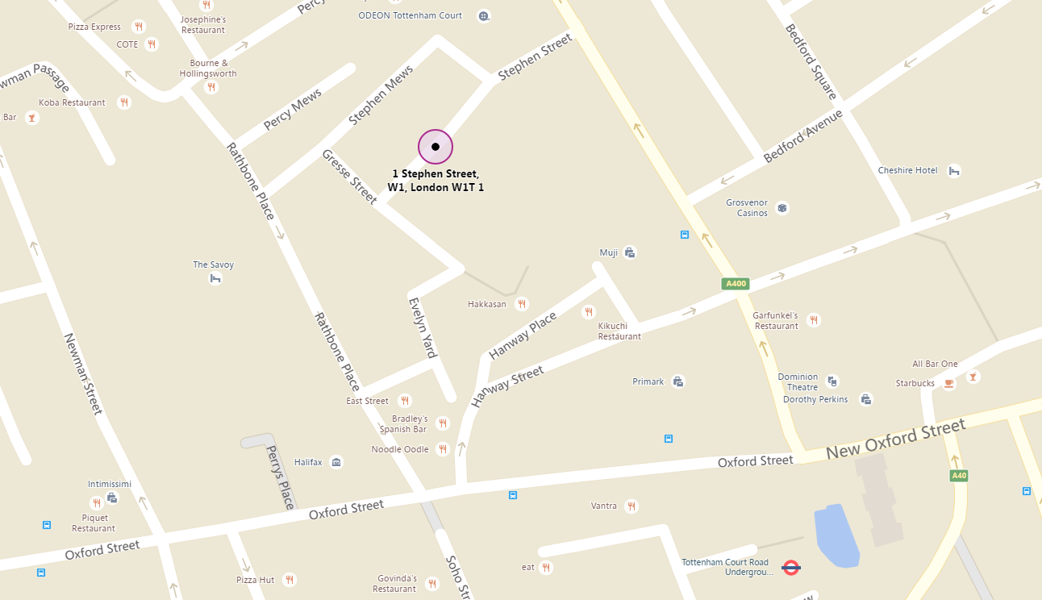

**Objectives:**

* The day seeks to provide students with a unique insight into the television production and format business, including the development process for the creation of ideas for new formats considered within a legal and compliance framework. Students will be given coaching in the art of presentation (including the use of voice and body language) and put those skills to the test as part of a fun team challenge.

|  |  |  |
| --- | --- | --- |
| **Time** | **Activity** | **Presenters** |
| 9.30-9.45 | Welcome and Introduction to Fremantle | Jacquie Moreton, General Counsel |
| 9.45 -11.00 | TV format development brainstorming session | Various members of development teams |
| 11.00 – 11.45 | Key considerations for TV formats | Damian Kent (Legal and Business Affairs) |
| 11.45-12.45 | Team Activity – Advanced brainstorming of creative concepts for a new TV format | Various members of development teams |
| 12.45-1.45 | Lunch |  |
| 1.45 -2.45 | Presentation Skills | Stephanie Schonfield, Actress |
| 2.45-3.30 | Team Activity – Preparation for a presentation of a new TV format | Various members of development teams |
| 3.30-4.30 | Team Activity – Presentation | Levina Negi (VP, Global Acquisitions and Development), Lucas Green (Head of Development, Entertainment), Tony Stern (EVP Commercial & Business Affairs) |
| 4.30-4.45 | Break |  |
| 4.45-5.00 | Round Up | Levina Negi (VP, Global Acquisitions and Development), Lucas Green (Head of Development, Entertainment), Tony Stern (EVP Commercial & Business Affairs) |

**Day 1: [insert day/date]**

[INSERT ORGANISATION LOGO HERE]

**Contact person on the day:** [Name]

[job title] [organisation]

**Location:** [address]

**Directions:** [include brief directions / instructions re meeting point here]

[INSERT BING MAPS SCREENSHOT OR OFFICIAL MAP HERE]

**Objectives:**

* [Insert example objectives here]

|  |  |  |
| --- | --- | --- |
| **Time** | **Activity** | **Presenters** |
|  |  |  |
|  |  |  |
|  |  |  |
|  |  |  |
|  |  |  |
|  |  |  |
|  |  |  |
|  | Complete feedback form |  |

[INSERT ORGANISATION LOGO HERE]

**Day 2: [insert day/date]**

**Contact person on the day:** [Name]

[job title] [organisation]

**Location:** [address]

**Directions:** [include brief directions / instructions re meeting point here]

[INSERT BING MAPS SCREENSHOT OR OFFICIAL MAP HERE]

**Objectives:**

* [Insert example objectives here]

|  |  |  |
| --- | --- | --- |
| **Time** | **Activity** | **Presenters** |
|  |  |  |
|  |  |  |
|  |  |  |
|  |  |  |
|  |  |  |
|  |  |  |
|  |  |  |
|  | Complete feedback form |  |

**Day 3: [insert day/date]**

[INSERT ORGANISATION LOGO HERE]

**Contact person on the day:** [Name]

[job title] [organisation]

**Location:** [address]

**Directions:** [include brief directions / instructions re meeting point here]

[INSERT BING MAPS SCREENSHOT OR OFFICIAL MAP HERE]

**Objectives:**

* [Insert example objectives here]

|  |  |  |
| --- | --- | --- |
| **Time** | **Activity** | **Presenters** |
|  |  |  |
|  |  |  |
|  |  |  |
|  |  |  |
|  |  |  |
|  |  |  |
|  |  |  |
|  | Complete feedback form |  |

**Day 4: [insert day/date]**

[INSERT ORGANISATION LOGO HERE]

**Contact person on the day:** [Name]

[job title] [organisation]

**Location:** [address]

**Directions:** [include brief directions / instructions re meeting point here]

[INSERT BING MAPS SCREENSHOT OR OFFICIAL MAP HERE]

**Objectives:**

* [Insert example objectives here]

|  |  |  |
| --- | --- | --- |
| **Time** | **Activity** | **Presenters** |
|  |  |  |
|  |  |  |
|  |  |  |
|  |  |  |
|  |  |  |
|  |  |  |
|  |  |  |
|  | Complete feedback form |  |

**Day 5: [insert day/date]**

[INSERT ORGANISATION LOGO HERE]

**Contact person on the day:** [Name]

[job title] [organisation]

**Location:** [address]

**Directions:** [include brief directions / instructions re meeting point here]

[INSERT BING MAPS SCREENSHOT OR OFFICIAL MAP HERE]

**Objectives:**

* [Insert example objectives here]

|  |  |  |
| --- | --- | --- |
| **Time** | **Activity** | **Presenters** |
|  |  |  |
|  |  |  |
|  |  |  |
|  | Lunch – complete testimonial forms and post scheme survey |  |
|  |  |  |
|  |  |  |
|  | Complete feedback form |  |
|  | Graduation ceremony – presentation of certificates |  |

**Log book**

13

Full name:

School:

### WELCOME TO THE WORK INSIGHT AND SKILLS PROGRAMME!

This logbook is for you to record all that you have been doing over the week and what you have learnt from it. Thinking about what you have learned will help you to:

1. Focus on tasks and goals;
2. Reflect and evaluate your experience;
3. Talk about your experience in future university or job interviews.

There are many important skills that professionals need to have. We would like you to focus on the following during your week:

1. Influencing and Negotiation skills – listening to others and constructively arguing your position.
2. Leadership and Teamwork – working as a team member and leading when appropriate.
3. Resilience and Goal Planning – bouncing back and planning to measure pressure.
4. Business skills – understanding how different types of businesses operate.
5. Presentation skills – the ability to present in writing and verbally.
6. Building Relationships – the ability to confidently meet people and create a positive impact.

We hope you enjoy your experience, it is a fantastic opportunity – make the most of it! Here are a few top tips for success:

* Be on time
* Smile
* Ask lots of questions

• Give 100%!

## Learning log

Describe what you did and what you have achieved:

Day One

Day Two

Day Three

Day Four

Day Five

## Learning log

Describe the skills that you used and how you used them.

Day One

Day Two

Day Three

Day Four

Day Five

## Learning log

What challenges have you faced? What have you learnt from them?

Day One

Day Two

Day Three

Day Four

Day Five